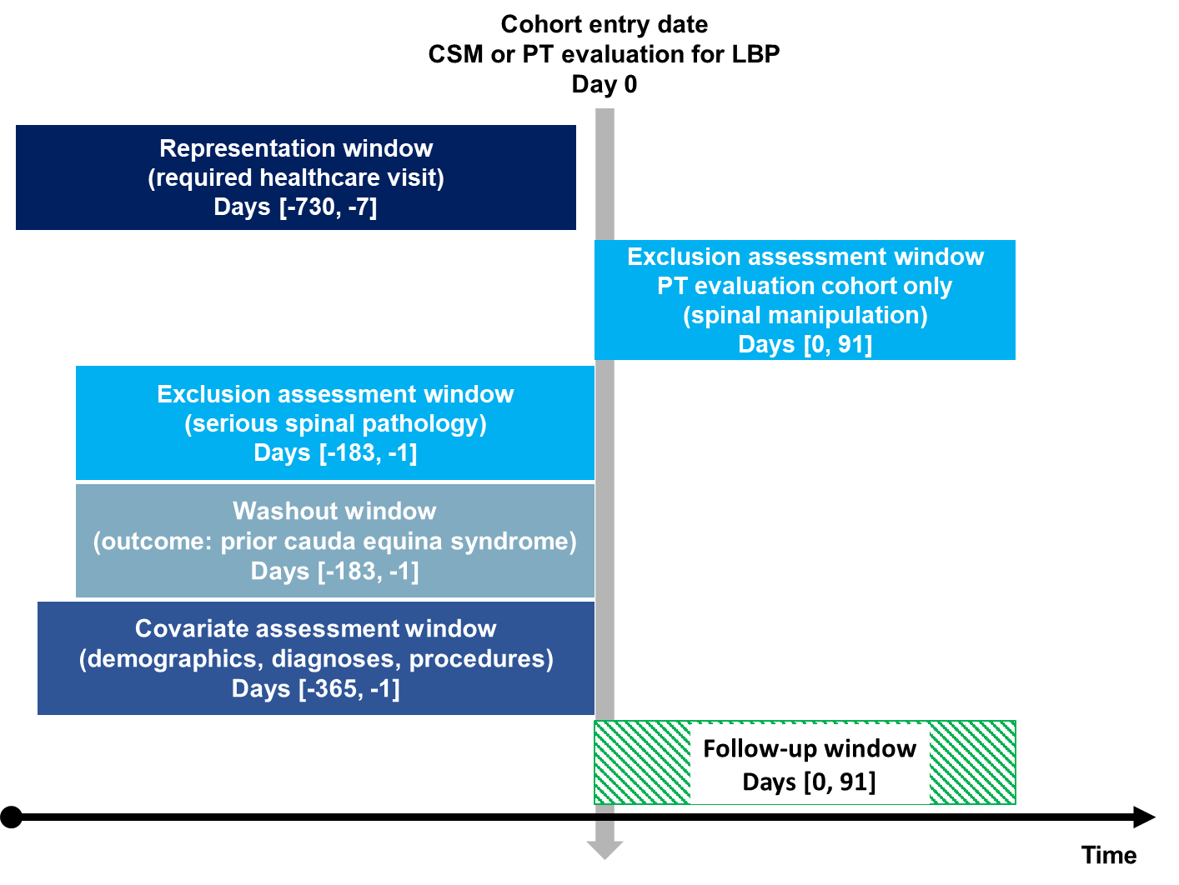
S1 Figure: Study design. The vertical arrow represents the index date of the first co-occurrence of a diagnosis of low back pain with either chiropractic spinal manipulation or physical therapy evaluation. Windows to the left of this arrow represent time periods preceding the index date over a span of days [#,#]. The window to the right of the arrow indicates events after the index date. The “∞” indicates that the time window extends as far retrospectively as data are available for each patient. Abbreviations: Chiropractic spinal manipulation (CSM), low back pain (LBP), physical therapy (PT). Image adapted by Robert J. Trager using a Creative Commons template [1].
Reference:
1. Schneeweiss S, A. Rassen J, S. Brown J, J. Rothman K, Happe L, Arlett P, et al. Graphical Depiction of Longitudinal Study Designs in Health Care Databases. Ann Intern Med. 2019;170:398–406.

