        - – ICD-9/ICD-10 Codes used for Patient Identification Title
ICD - 10 CODES
M41.25 Other idiopathic scoliosis, thoracolumbar region
M41.26 Other idiopathic scoliosis, lumbar region
M41.27 Other idiopathic scoliosis, lumbosacral region
M41.35 Thoracogenic scoliosis, thoracolumbar region
M41.45 Neuromuscular scoliosis, thoracolumbar region
M41.46 Neuromuscular scoliosis, lumbar region
M41.47 Neuromuscular scoliosis, lumbosacral region
M41.55 Other secondary scoliosis, thoracolumbar region
M41.56 Other secondary scoliosis, lumbar region
M41.57 Other secondary scoliosis, lumbosacral region
M41.85 Other forms of scoliosis, thoracolumbar region
M41.86 Other forms of scoliosis, lumbar region
M41.87 Other forms of scoliosis, lumbosacral region
M42.05 Juvenile osteochondrosis of spine, thoracolumbar region
M42.06 Juvenile osteochondrosis of spine, lumbar region
M42.07 Juvenile osteochondrosis of spine, lumbosacral region
M42.09 Juvenile osteochondrosis of spine, multiple sites in spine
M42.15 Adult osteochondrosis of spine, thoracolumbar region
M42.16 Adult osteochondrosis of spine, lumbar region
M42.17 Adult osteochondrosis of spine, lumbosacral region
M42.19 Adult osteochondrosis of spine, multiple sites in spine
M43.05 Spondylolysis, thoracolumbar region
M43.06 Spondylolysis, lumbar region
M43.07 Spondylolysis, lumbosacral region
M43.09 Spondylolysis, multiple sites in spine
M43.15 Spondylolisthesis, thoracolumbar region
M43.16 Spondylolisthesis, lumbar region
M43.17 Spondylolisthesis, lumbosacral region
M43.19 Spondylolisthesis, multiple sites in spine
M43.25 Fusion of spine, thoracolumbar region
M43.26 Fusion of spine, lumbar region
M43.27 Fusion of spine, lumbosacral region
M43.5X5 Other recurrent vertebral dislocation, thoracolumbar region
M43.5X6 Other recurrent vertebral dislocation, lumbar region
M43.5X7 Other recurrent vertebral dislocation, lumbosacral region
M43.8X5 Other specified deforming dorsopathies, thoracolumbar region
M43.8X6 Other specified deforming dorsopathies, lumbar region
M43.8X7 Other specified deforming dorsopathies, lumbosacral region
M46.05 Spinal enthesopathy, thoracolumbar region
M46.06 Spinal enthesopathy, lumbar region
M46.07 Spinal enthesopathy, lumbosacral region
M46.09 Spinal enthesopathy, multiple sites in spine
M46.25 Osteomyelitis of vertebra, thoracolumbar region
M46.26 Osteomyelitis of vertebra, lumbar region
M46.27 Osteomyelitis of vertebra, lumbosacral region
M46.35 Infection of intvrt disc (pyogenic), thoracolumbar region
M46.36 Infection of intervertebral disc (pyogenic), lumbar region
M46.37 Infection of intvrt disc (pyogenic), lumbosacral region
M46.39 Infection of intvrt disc (pyogenic), multiple sites in spine
M46.45 Discitis, unspecified, thoracolumbar region
M46.46 Discitis, unspecified, lumbar region
M46.47 Discitis, unspecified, lumbosacral region
M46.49 Discitis, unspecified, multiple sites in spine
M46.55 Other infective spondylopathies, thoracolumbar region
M46.56 Other infective spondylopathies, lumbar region
M46.57 Other infective spondylopathies, lumbosacral region
M46.59 Other infective spondylopathies, multiple sites in spine
M46.85 Oth inflammatory spondylopathies, thoracolumbar region
M46.86 Other specified inflammatory spondylopathies, lumbar region
M46.87 Oth inflammatory spondylopathies, lumbosacral region
M46.89 Oth inflammatory spondylopathies, multiple sites in spine
M46.95 Unspecified inflammatory spondylopathy, thoracolumbar region
M46.96 Unspecified inflammatory spondylopathy, lumbar region
M46.97 Unspecified inflammatory spondylopathy, lumbosacral region
M46.99 Unsp inflammatory spondylopathy, multiple sites in spine
M47.15 Other spondylosis with myelopathy, thoracolumbar region
M47.16 Other spondylosis with myelopathy, lumbar region
M47.17 Other spondylosis with myelopathy, lumbosacral region
M47.25 Other spondylosis with radiculopathy, thoracolumbar region
M47.26 Other spondylosis with radiculopathy, lumbar region
M47.27 Other spondylosis with radiculopathy, lumbosacral region
M47.815 Spondyls w/o myelopathy or radiculopathy, thoracolum region
M47.816 Spondylosis w/o myelopathy or radiculopathy, lumbar region
M47.817 Spondyls w/o myelopathy or radiculopathy, lumbosacr region
M47.895 Other spondylosis, thoracolumbar region
M47.896 Other spondylosis, lumbar region
M47.897 Other spondylosis, lumbosacral region
M48.05 Spinal stenosis, thoracolumbar region
M48.06 Spinal stenosis, lumbar region
M48.07 Spinal stenosis, lumbosacral region
M48.15 Ankylosing hyperostosis [Forestier], thoracolumbar region
M48.16 Ankylosing hyperostosis [Forestier], lumbar region
M48.17 Ankylosing hyperostosis [Forestier], lumbosacral region
M48.19 Ankylosing hyperostosis [Forestier], multiple sites in spine
M48.25 Kissing spine, thoracolumbar region
M48.26 Kissing spine, lumbar region
M48.27 Kissing spine, lumbosacral region
M48.35 Traumatic spondylopathy, thoracolumbar region
M48.36 Traumatic spondylopathy, lumbar region
M48.37 Traumatic spondylopathy, lumbosacral region
M48.8X5 Other specified spondylopathies, thoracolumbar region
M48.8X6 Other specified spondylopathies, lumbar region
M48.8X7 Other specified spondylopathies, lumbosacral region
M51 Thoracic, thoracolum, and lumbosacral intvrt disc disorders
M51.0 Thoracic, thrclm and lumbosacr intvrt disc disord w myelpath
M51.05 Intvrt disc disorders w myelopathy, thoracolumbar region
M51.06 Intervertebral disc disorders with myelopathy, lumbar region
M51.07 Intvrt disc disorders w myelopathy, lumbosacral region
M51.1 Thor, thrclm & lumbosacr intvrt disc disord w radiculopathy
M51.15 Intvrt disc disorders w radiculopathy, thoracolumbar region
M51.16 Intervertebral disc disorders w radiculopathy, lumbar region
M51.17 Intvrt disc disorders w radiculopathy, lumbosacral region
M51.2 Oth thoracic, thrclm and lumbosacr intvrt disc displacmnt
M51.25 Other intervertebral disc displacement, thoracolumbar region
M51.26 Other intervertebral disc displacement, lumbar region
M51.27 Other intervertebral disc displacement, lumbosacral region
M51.3 Oth thoracic, thrclm and lumbosacr intvrt disc degeneration
M51.35 Other intervertebral disc degeneration, thoracolumbar region
M51.36 Other intervertebral disc degeneration, lumbar region
M51.37 Other intervertebral disc degeneration, lumbosacral region
M51.45 Schmorl's nodes, thoracolumbar region
M51.46 Schmorl's nodes, lumbar region
M51.47 Schmorl's nodes, lumbosacral region
M51.8 Oth thoracic, thoracolum and lumbosacr intvrt disc disorders
M51.85 Other intervertebral disc disorders, thoracolumbar region
M51.86 Other intervertebral disc disorders, lumbar region
M51.87 Other intervertebral disc disorders, lumbosacral region
M51.9 Unsp thoracic, thoracolum and lumbosacr intvrt disc disorder
M53 Other and unspecified dorsopathies, not elsewhere classified
M53.2X5 Spinal instabilities, thoracolumbar region
M53.2X6 Spinal instabilities, lumbar region
M53.2X7 Spinal instabilities, lumbosacral region
M53.3 Sacrococcygeal disorders, not elsewhere classified
M53.85 Other specified dorsopathies, thoracolumbar region
M53.86 Other specified dorsopathies, lumbar region
M53.87 Other specified dorsopathies, lumbosacral region
M54.05 Panniculitis affecting regions of neck/bk, thoracolum region
M54.06 Panniculitis affecting regions of neck/bk, lumbar region
M54.07 Panniculitis affecting regions of neck/bk, lumbosacr region
M54.09 Panniculitis aff regions, neck/bk, multiple sites in spine
M54.15 Radiculopathy, thoracolumbar region
M54.16 Radiculopathy, lumbar region
M54.17 Radiculopathy, lumbosacral region
M54.31 Sciatica, right side
M54.32 Sciatica, left side
M54.41 Lumbago with sciatica, right side
M54.42 Lumbago with sciatica, left side

ICD - 9 CODES
721 Spondylosis and allied disorders
721.3 Lumbosacral spondylosis without myelopathy
721.4 Thoracic or lumbar spondylosis with myelopathy
721.42 Spondylosis with myelopathy, lumbar region
721.5 Kissing spine
721.6 Ankylosing vertebral hyperostosis
721.7 Traumatic spondylopathy
721.8 Other allied disorders of spine
721.9 Spondylosis of unspecified site
721.90 Spondylosis of unspecified site without mention of myelopathy
721.91 Spondylosis of unspecified site with myelopathy
722 Intervertebral disc disorders
722.1 Displacement of thoracic or lumbar disc without myelopathy
722.10 Displacement of lumbar disc without myelopathy
722.2 Displacement of disc, site unspecified, without myelopathy
722.3 Schmorl's nodes
722.30 Schmorl's nodes, unspecified region
722.32 Schmorl's nodes, lumbar region
722.39 Schmorl's nodes, other spinal region
722.5 Degeneration of thoracic or lumbar intervertebral disc
722.51 Degeneration of thoracic or thoracolumbar intervertebral disc
722.52 Degeneration of lumbar or lumbosacral intervertebral disc
722.6 Degeneration of intervertebral disc, site unspecified
722.7 Intervertebral disc disorder with myelopathy
722.70 Intervertebral disc disorder with myelopathy, unspecified region
722.73 Intervertebral lumbar disc disorder with myelopathy, lumbar region
722.8 Postlaminectomy syndrome
722.80 Postlaminectomy syndrome, unspecified region
722.83 Postlaminectomy syndrome, lumbar region
722.9 Other and unspecified disc disorder
722.90 Other and unspecified disc disorder of unspecified region
722.93 Other and unspecified disc disorder of lumbar region
724 Other and unspecified disorders of back
724.0 Spinal stenosis, other than cervical
724.00 Spinal stenosis, unspecified region other than cervical
724.02 Spinal stenosis of lumbar region, without neurogenic claudication
724.03 Spinal stenosis of lumbar region, with neurogenic claudication
724.09 Spinal stenosis, other region other than cervical
724.2 Lumbago
724.3 Sciatica
724.4 Thoracic or lumbosacral neuritis or radiculitis, unspecified
724.5 Unspecified backache
724.6 Disorders of sacrum
724.8 Other symptoms referable to back
724.9 Other unspecified back disorder
729.2 Unspecified neuralgia, neuritis, and radiculitis
738.4 Acquired spondylolisthesis
738.5 Other acquired deformity of back or spine
738.6 Acquired deformity of pelvis
739 Nonallopathic lesions, not elsewhere classified
739.3 Nonallopathic lesion of lumbar region, not elsewhere classified
739.4 Nonallopathic lesion of sacral region, not elsewhere classified
739.5 Nonallopathic lesion of pelvic region, not elsewhere classified
756.11 Congenital spondylolysis, lumbosacral region
756.12 Congenital spondylolisthesis
846 Sprains and strains of sacroiliac region
846.0 Sprain and strain of lumbosacral (joint) (ligament)
846.1 Sprain and strain of sacroiliac (ligament)
846.2 Sprain and strain of sacrospinatus (ligament)
846.3 Sprain and strain of sacrotuberous (ligament)
846.8 Other specified sites of sacroiliac region sprain and strain
846.9 Unspecified site of sacroiliac region sprain and strain
847 Sprains and strains of other and unspecified parts of back
847.2 Lumbar sprain and strain
847.3 Sprain and strain of sacrum
847.9 Sprain and strain of unspecified site of back

        - – ICD-9/10 Codes for exclusion
592.0 Kidney Stones
N20.0 Calculus of Kidney
594.0 Bladder Stones
N21.0 Calculus of Bladder
574.2 Gall Bladder Stones
K80.20 Calculus of Gallbladder
599.0 Urinary Tract infection
N39.0 Urinary Tract infection
S32.x Fracture of the Lumbar Spine, Sacrum, Pelvis
805 Fracture of vertebral column without mention of spinal cord injury
808 Fracture of pelvis
809 Ill-defined fractures of bones of trunk
733.13 Pathologic fracture of vertebra
M48.50XA Collapsed vertebra, not elsewhere classified, site unspecified, initial encounter for fracture
M80.08XA Age-related osteoporosis with current pathological fracture, vertebra(e), initial encounter for fracture
M84.48XA Pathological fracture, other site, initial encounter for fracture
M84.68XA Pathological fracture in other disease, other site, initial encounter for fracture
733.98 Stress fracture of the pelvis
M84.350A Stress fracture, pelvis, initial encounter for fracture
730.2 Unspecified osteomyelitis, site unspecified
M.86.9 Osteomyelitis
720.0 Ankylosing spondylitis
M45.9 Ankylosing spondylitis of unspecified sites in spine
S34.3XXA Injury of cauda equina, initial encounter
952.4 Cauda equina spinal cord injury without evidence of spinal bone injury
140 – 209 Malignant Neoplasms
C00 – C96 Malignant Neoplasms
O00 – O9A Pregnancy, childbirth, and the puerperium

        - – “Other” First Contact Providers
Acupuncture
Ambulatory surgery
Anesthesiology
Cardiology
Critical care medicine
Durable medical equipment & ox
Emergency medicine aca
Gastroenterology
Hematology/oncology
Home health
Hospital
Infectious diseases
Lab
Oncology
Ophthalmology
Palliative medicine
Pathology
Pediatric critical care medici
Pediatrics
Psychiatry
Psychology
Radiology
Radiology-mri
Rural clinic reimbursement
Skilled nursing facility-adult
Specialty products/services-bo
Surgery (critical care)
Transportation services
Unknown
Urology

        - – SPMI ICD-9/10 codes
ICD-9-CM Group codes:
295 Schizophrenic Disorders
296 Episodic Mood Disorders

ICD-9-CM codes:
298.9 Unspecific Psychosis
301.83 Borderline Personality Disorder

ICD-10-CM Group codes:
F20 Schizophrenia
F25 Schizoaffective Disorders

ICD-10-CM codes:
F29 Unspecified psychosis not due to a substance or known physiological condition
F30.10 Manic Episode Without Psychotic Symptoms Unspecified
F30.11 Manic Episode Without Psychotic Symptoms Mild
F30.12 Manic Episode Without Psychotic Symptoms Moderate
F30.13 Manic Episode, Severe, Without Psychotic Symptoms
F30.2 Manic Episode, Severe, With Psychotic Symptoms
F30.3 Manic Episode In Partial Remission
F30.4 Manic Episode In Full Remission
F30.8 Other Manic Episode
F30.9 Manic Episode, Unspecified
F31.0 Bipolar disorder, current episode hypomanic
F31.10 Bipolar disorder, current episode manic without psychotic features unspecified
F31.11 Bipolar disorder, current episode manic without psychotic features mild
F31.12 Bipolar disorder, current episode manic without psychotic features moderate
F31.13 Bipolar disorder, current episode manic without psychotic features severe
F31.2 Bipolar disorder, current episode manic severe with psychotic features
F31.30 Bipolar disorder, current episode depressed, unspecified
F31.31 Bipolar disorder, current episode depressed, mild
F31.32 Bipolar disorder, current episode depressed, moderate
F31.4 Bipolar disorder, current episode depressed, severe, without psychotic features
F31.5 Bipolar disorder, current episode depressed, severe, with psychotic features
F31.60 Bipolar disorder, current episode mixed unspecified
F31.61 Bipolar disorder, current episode mixed mild
F31.62 Bipolar disorder, current episode mixed moderate
F31.63 Bipolar disorder, current episode mixed, severe, without psychotic features
F31.64 Bipolar disorder, current episode mixed, severe, with psychotic features
F31.70 Bipolar disorder currently in remission, most recent episode unspecified
F31.71 Bipolar disorder, in partial remission, most recent episode hypomanic
F31.72 Bipolar disorder, in full remission, most recent episode hypomanic
F31.73 Bipolar disorder, in partial remission, most recent episode manic
F31.74 Bipolar disorder, in full remission, most recent episode manic
F31.75 Bipolar disorder, in partial remission, most recent episode depressed
F31.76 Bipolar disorder, in full remission, most recent episode depressed
F31.77 Bipolar disorder, in partial remission, most recent episode mixed
F31.78 Bipolar disorder, in full remission, most recent episode mixed F31.70
F31.81 Bipolar II disorder
F31.89 Other bipolar disorder F31.9
F32.0 Major depressive disorder, single episode, mild
F32.1 Major depressive disorder, single episode, moderate
F32.2 Major depressive disorder, single episode, severe without psychotic features
F32.3 Major depressive disorder, single episode, severe with psychotic features
F32.4 Major depressive disorder, single episode, in partial remission
F32.5 Major depressive disorder, single episode, in full remission
F32.89 Other Specified Depressive Episodes
F32.9 Major depressive disorder, single episode, unspecified
F33.0 Major depressive disorder, recurrent, mild
F33.1 Major depressive disorder, recurrent, moderate
F33.2 Major depressive disorder, recurrent severe without psychotic features
F33.3 Major depressive disorder, recurrent, severe with psychotic symptoms
F33.4 Major depressive disorder, recurrent, in remission
F33.40 Major depressive disorder, recurrent, unspecified
F33.41 Major depressive disorder, recurrent, in partial remission
F33.42 Major depressive disorder, recurrent, in full remission
F33.8 Other recurrent depressive disorders
F33.9 Major depressive disorder, recurrent, unspecified F34.81
F34.89 Other specified persistent mood disorders
F34.9 Persistent mood [affective] disorder, unspecifiedF39
F60.3 Borderline Personality Disorder

        - – Outcomes Codes

Surgery – Drg Codes
304 Dorsal & Lumbar Fusion Proc Except For Curvature Of Back
321 Cervical Spinal Fusion & Other Back/Neck Proc Exc Disc Excis/ Decomp
453 Combined Anterior/Posterior Spinal Fusion With Mcc
454 Combined Anterior/Posterior Spinal Fusion With Cc
455 Combined Anterior/Posterior Spinal Fusion Without Cc/Mcc
456 Spinal Fusion Except Cervical With Spinal Curvature Or Malignancy Or Infection Or Extensive Fusions With Mcc
457 Spinal Fusion Except Cervical With Spinal Curvature Or Malignancy Or Infection Or Extensive Fusions With Cc
458 Spinal Fusion Except Cervical With Spinal Curvature Or Malignancy Or Infection Or Extensive Fusions Without Cc/Mcc
459 Spinal Fusion Except Cervical With Mcc
460 Spinal Fusion Except Cervical Without Mcc
490 Back & Neck Procedure Except Spinal Fusion With Complication Or Comorbidity (Cc)/Major Complication Or Comorbidity (Mcc) Or Disc Devices/Neurostimulators
491 Back & Neck Procedure Except Spinal Fusion Without Complication Or Comorbidity (Cc)/Major Complication Or Comorbidity (Mcc)
496 Local Excision And Removal Of Internal Fixation Devices Except Hip And Femur With Complication Or Comorbidity (Cc)
497 Local Excision And Removal Internal Fixation Devices Except Hip And Femur Without Complication Or Comorbidity (Cc)/Major Complication Or Comorbidity (Mcc)
498 Local Excision And Removal Internal Fixation Devices Of Hip And Femur With Complication Or Comorbidity (Cc)/Major Complication Or Comorbidity (Mcc)
499 Local Excision And Removal Internal Fixation Devices Of Hip And Femur Without Complication Or Comorbidity (Cc)/Major Complication Or Comorbidity (Mcc)
500 Soft Tissue Procedures With Major Complication Or Comorbidity (Mcc)
551 Medical Back Problems With Major Complication Or Comorbidity (Mcc)
552 Medical Back Problems Without Major Complication Or Comorbidity (Mcc)

Injections – CPT-4 codes
C9209 Injection, laronidase, per 2.9 mg
G0260 Injection procedure for sacroiliac joint; provision of anesthetic, steroid and/or other therapeutic agent, with or without arthrography
J0131 Acetaminophen injection
J1020 Injection, methylprednisolone acetate, 20 mg
J1030 Injection, methylprednisolone acetate, 40 mg
J1040 Injection, methylprednisolone acetate, 80 mg
J1100 Injection, dihydroergotamine mesylate, per 1 mg
J1170 Injection, dihydroergotamine mesylate, per 1 mg
J1885 Injection, ketorolac tromethamine, per 15 mg
J2001 Injection, lidocaine hcl for intravenous infusion, 10 mg
J2175 Injection, meperidine hydrochloride, per 100 mg
J2270 Injection, morphine sulfate, up to 10 mg
J2274 Injection, morphine sulfate, preservative-free for epidural or intrathecal use, 10 mg
J2400 Injection, chloroprocaine hydrochloride, per 30 ml
J2920 Injection, methylprednisolone sodium succinate, up to 40 mg
J2930 Injection, methylprednisolone sodium succinate, up to 125 mg
X0620 Injection Nerve Block Procedures
01991 Under Anesthesia for Other Procedures
01992 Under Anesthesia for Other Procedures
20526 Under General Introduction or Removal Procedures on the Musculoskeletal System
20550 Under General Introduction or Removal Procedures on the Musculoskeletal System
20551 Under General Introduction or Removal Procedures on the Musculoskeletal System
20552 Under General Introduction or Removal Procedures on the Musculoskeletal System
20553 Under General Introduction or Removal Procedures on the Musculoskeletal System
27096 Under Introduction or Removal Procedures on the Pelvis and Hip Joint
62273 Under Injection, Drainage, or Aspiration Procedures on the Spine and Spinal Cord
62282 Under Injection, Drainage, or Aspiration Procedures on the Spine and Spinal Cord
62310 Epidural Injection
62311 Epidural Injection
62319 Epidural Injection
62322 Epidural Injection
62323 Epidural Injection
62326 Under Injection, Drainage, or Aspiration Procedures on the Spine and Spinal Cord
62327 Under Injection, Drainage, or Aspiration Procedures on the Spine and Spinal Cord
64445 Under Introduction/Injection of Anesthetic Agent (Nerve Block), Diagnostic or Therapeutic Procedures on the Somatic Nerves
64447 Under Introduction/Injection of Anesthetic Agent (Nerve Block), Diagnostic or Therapeutic Procedures on the Somatic Nerves
64449 Under Introduction/Injection of Anesthetic Agent (Nerve Block), Diagnostic or Therapeutic Procedures on the Somatic Nerves
64475 Facet Joint Injection
64476 Facet Joint Injection
64483 Under Introduction/Injection of Anesthetic Agent (Nerve Block), Diagnostic or Therapeutic Procedures on the Somatic Nerves
64484 Under Introduction/Injection of Anesthetic Agent (Nerve Block), Diagnostic or Therapeutic Procedures on the Somatic Nerves
64493 Under Introduction/Injection of Anesthetic Agent (Nerve Block), Diagnostic or Therapeutic Procedures on the Paravertebral Spinal Nerves and Branches
64494 Under Introduction/Injection of Anesthetic Agent (Nerve Block), Diagnostic or Therapeutic Procedures on the Paravertebral Spinal Nerves and Branches
64495 Under Introduction/Injection of Anesthetic Agent (Nerve Block), Diagnostic or Therapeutic Procedures on the Paravertebral Spinal Nerves and Branches

        - – Kaplan Meier Curves
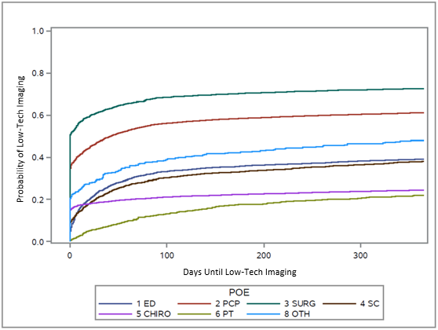

Figure 2.8.2 Probability of Low Cost Imaging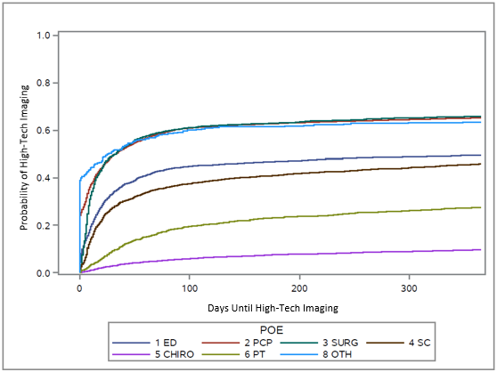

Figure 2.8.3 Probability of High Cost Imaging

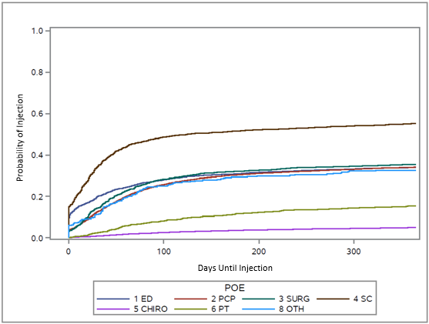

Figure 2.8.4 Probability of Injections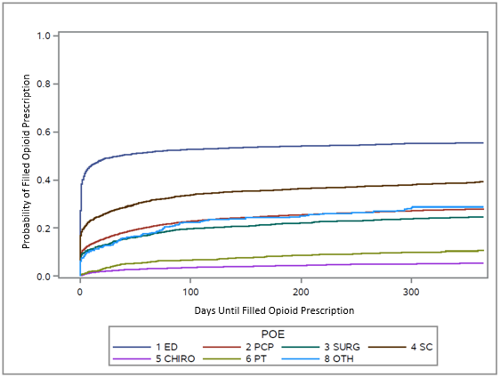

Figure 2.8.5 Probability of Filled Opioid Prescription
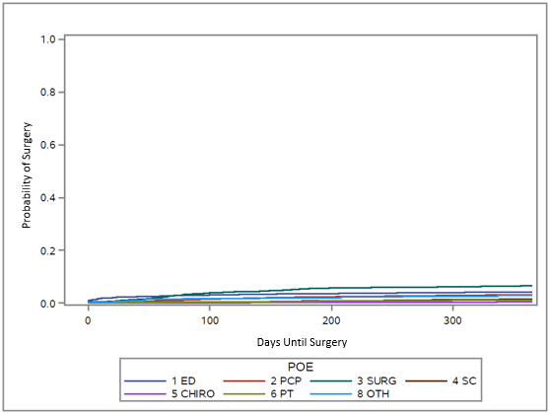

Figure 2.8.6 Probability of Surgical Intervention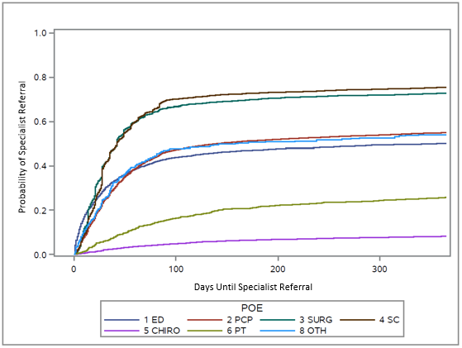

Figure 2.8.7 Probability of Specialist Referral
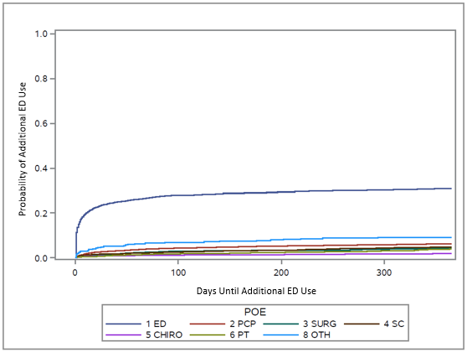

Figure 2.8.8 Probability of Unplanned Care Use
        - – Variable Definitions
Variable | Data Type | Description
Demographics | Dichotomous | Age, gender, insurance coverage (Medicare Advantage, Medicaid Managed, Commercial)
Charlson Comorbidity Index (CCI) | Continuous | 22 condition report gathered from administrative and self-report data that calculates a one-year mortality prediction.
CC- CHF  CC - CAD  CC - COPD  CC - DM  CC - HTN  CC - ANX  CC - DEP | Dichotomous | Dichotomized elements of the CCI including congestive heart failure (CHF), peripheral vascular disease (PVD), chronic obstructive pulmonary disease (COPD), diabetes (DM), hypertension (HTN), anxiety (ANX), and depression (DEP)
BMI >30 | Dichotomous | BMI gathered from available clinical and administrative data.
SPMI | Dichotomous | Individuals diagnosed with Schizophrenic Disorders, Episodic Mood Disorders, or Borderline Personality Disorders based on ICD-9/ICD-10 codes (Appendix D) over the previous 12-month period. This was included as a co-variate to control for members identified with SPMI who have “high behavioral health needs” and those identified without SPMI who are likely to have “low behavioral health needs.”
High Utilizers | Dichotomous | High utilizers were identified using internal predictive models that recognize members with increased service use. These models flag members with spending above a specific threshold or those with escalating utilization. Using a combination of claims data, pharmacy data and demographic data, the models predict whether utilization for flagged members will continue to escalate or remain above the spending threshold over the following 12 months. Members with end-stage renal disease, transplant and cancer are excluded from the models as they are expected to have high spending and utilization.
Episode Length | Continuous | Date of the index visit for LBP to the date of the last claim with a LBP diagnosis code. An episode was considered “resolved” when a patient had 90 days without a claim for LBP.
Total Cost of Care | Continuous | Calculated as benefit allowed amount, including copays for all medical claims (including pharmacy claims), for 12 months following the index visit. LBP-related costs were defined as the medical and pharmacy claims associated ICD-9 / ICD-10
LBP Spend | Continuous | Calculated as benefit allowed amounT, including copays for all medical claims (including pharmacy claims), for 12 months following the index visit. LBP-related costs were defined as the medical and pharmacy claims associated ICD-9 / ICD-10 LBP diagnosis codes over the same for the 12 months following the index visit.
X-Ray (Low Tech) | Time to Event | Use of an X-Ray. Identified by CPT code, date, and presence of LBP related code in the primary billing position.
MRI/CT (High Tech) | Time to Event | Use of an MRI / CT. Identified by CPT code, date, and presence of LBP related code in the primary billing position.
Injection | Time to Event | Use of an injection. Identified by CPT code, date, and presence of LBP related code in the primary billing position.
Opioid Script Filled | Time to Event | An opioid prescription related to LBP was operationalized using pharmacy claims. When a prescription is filled, the fill date and the date the prescription was written are loaded into the claim. When the date the prescription was written coincided with a visit claim date that had a LBP related diagnosis code, that prescription was associated with the current LBP episode.
Surgery | Time to Event | Progression to surgery. Identified by DRG code, date, and presence of LBP related code in the primary billing position.
Specialist Referral | Time to Event | Visit to orthopedics, neurosurgery, physical medicine and rehabilitation, and/or pain management. Identified by CPT code, date, and presence of LBP related code in the primary billing position.
Unplanned Care Use | Time to Event | Additional care delivered in the ED. Identified by CPT code, date, and presence of LBP related code in the primary billing position.

