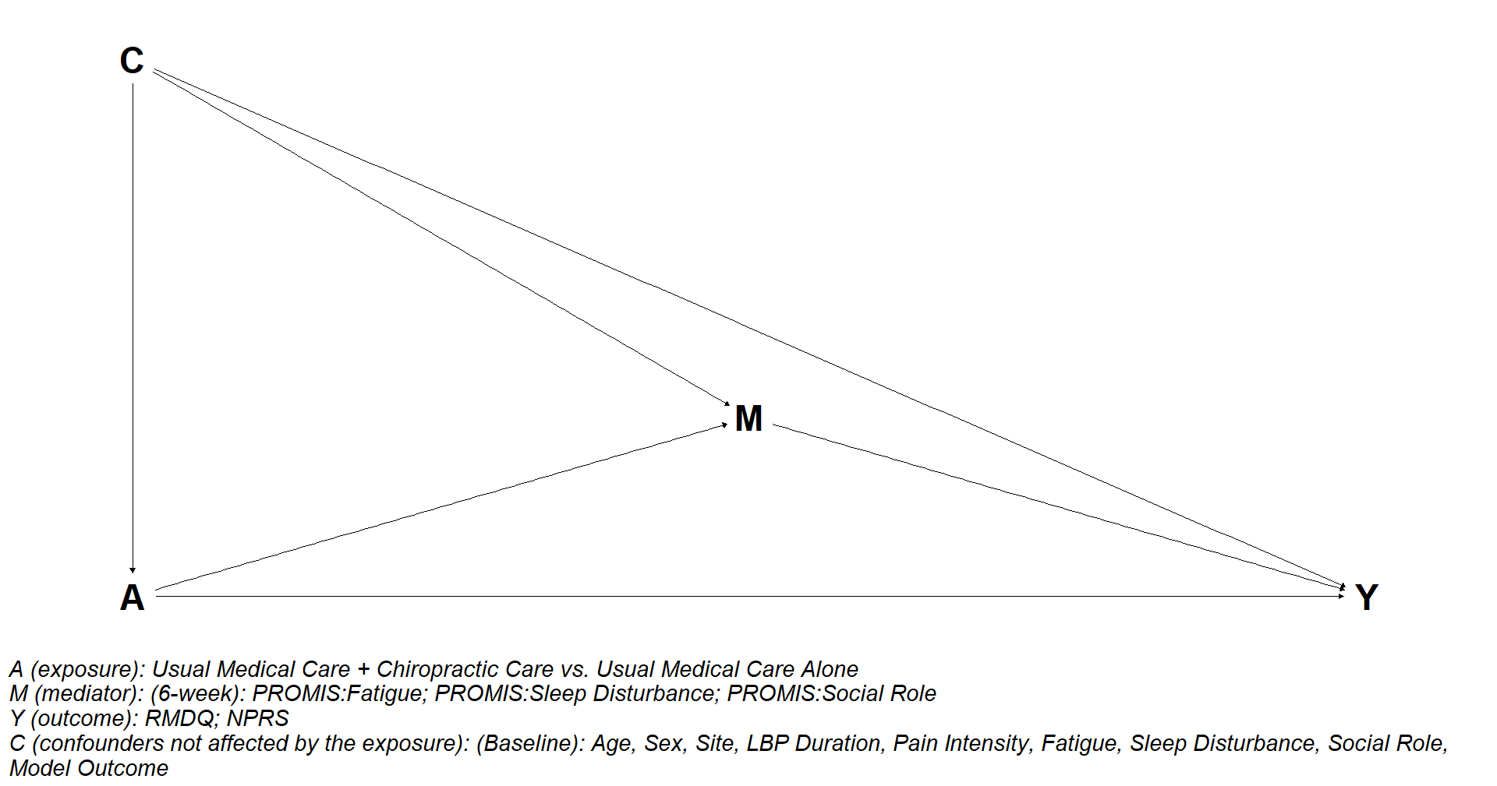
Figure S1. Directed acyclic graph for mediation of the effect of chiropractic care on 12- and 52-week RMDQ and NPRS.

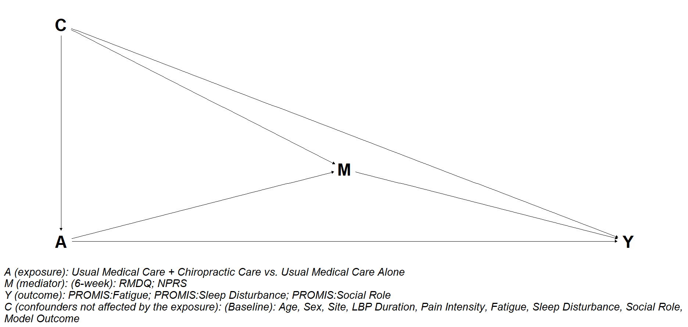
Figure S2. Directed acyclic graph for mediation of the effect of chiropractic care on 12- and 52-week PROMIS: fatigue, sleep disturbance, social role

