Stretching exercises, daily for 14 days

The exercises must be done every day for 14 days. It will take approximately 10 minutes.
Please follow the description provided.
Use the exercise diary to make sure you remember to do your exercises

Sustain each stretch for 30 minutes and repeat 3 times.
- Bend your head to your left. Place your left arm on top of your head and feel the stretch.
- Bend your head to your right. Place your right arm on top of your head and feel the stretch.

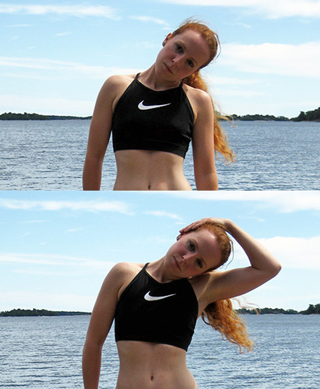

- Bend and rotate your head to the left. Place your left arm on top of your head and feel the stretch.
- Bend and rotate your head to the right. Place your right arm on top of your head and feel the stretch.

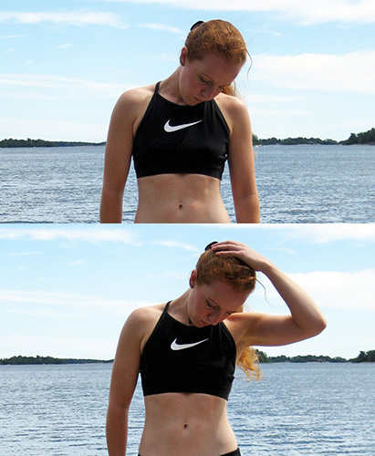

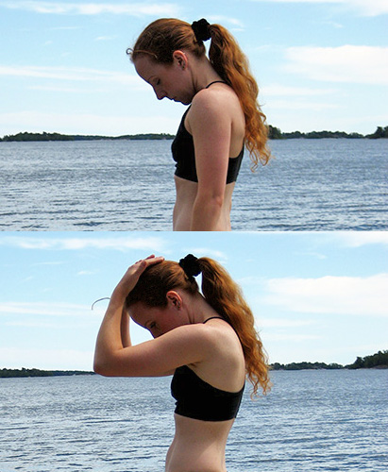
5: Bend your head forward. Place an arm on your head and feel the stretch.

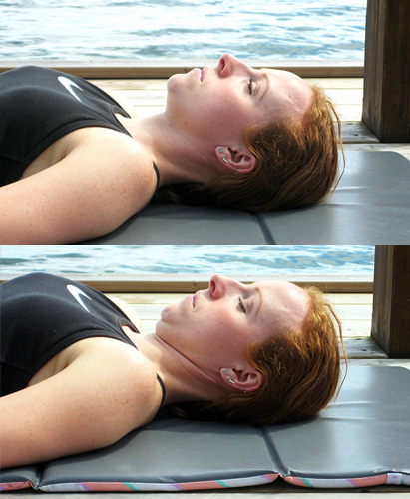
6: Finish off by sitting with your back straight, or lying flat on your back. Bring your chin back and hold for 3-5 seconds. Repeat 5 times.

Good luck!

Date for your first consultation with the chiropractor:_______________
CODE: _____________

Circle your answer every day
Day 1: Stretching performed following the instructions Yes No
Day 2: Stretching performed following the instructions Yes No
Day 3: Stretching performed following the instructions Yes No
Day 4: Stretching performed following the instructions Yes No
Day 5: Stretching performed following the instructions Yes No
Day 6: Stretching performed following the instructions Yes No
Day 7: Stretching performed following the instructions Yes No
Day 8: Stretching performed following the instructions Yes No
Day 9: Stretching performed following the instructions Yes No
Day 10: Stretching performed following the instructions Yes No
Day 11: Stretching performed following the instructions Yes No
Day 12: Stretching performed following the instructions Yes No
Day 13: Stretching performed following the instructions Yes No
Day 14: Stretching performed following the instructions Yes No
Comments: _________________________________________________________
______________________________________________________________________________

