S2 Fig. Invasive laser acupuncture procedure and electro acupuncture procedure
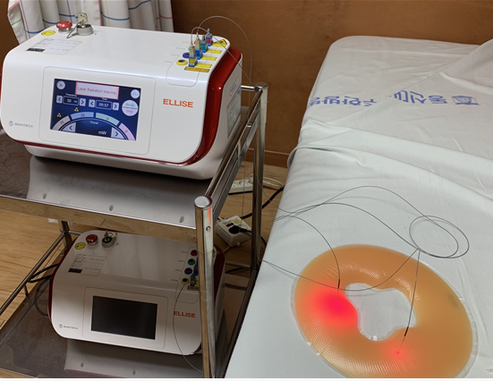
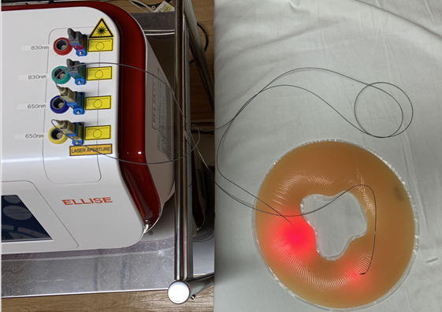
Invasive laser acupuncture procedure

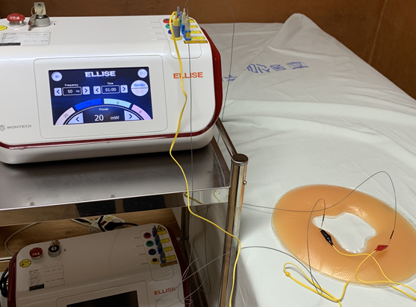
Electroacupuncture procedure

